**Property Particulars for Fassiefern, Killin**

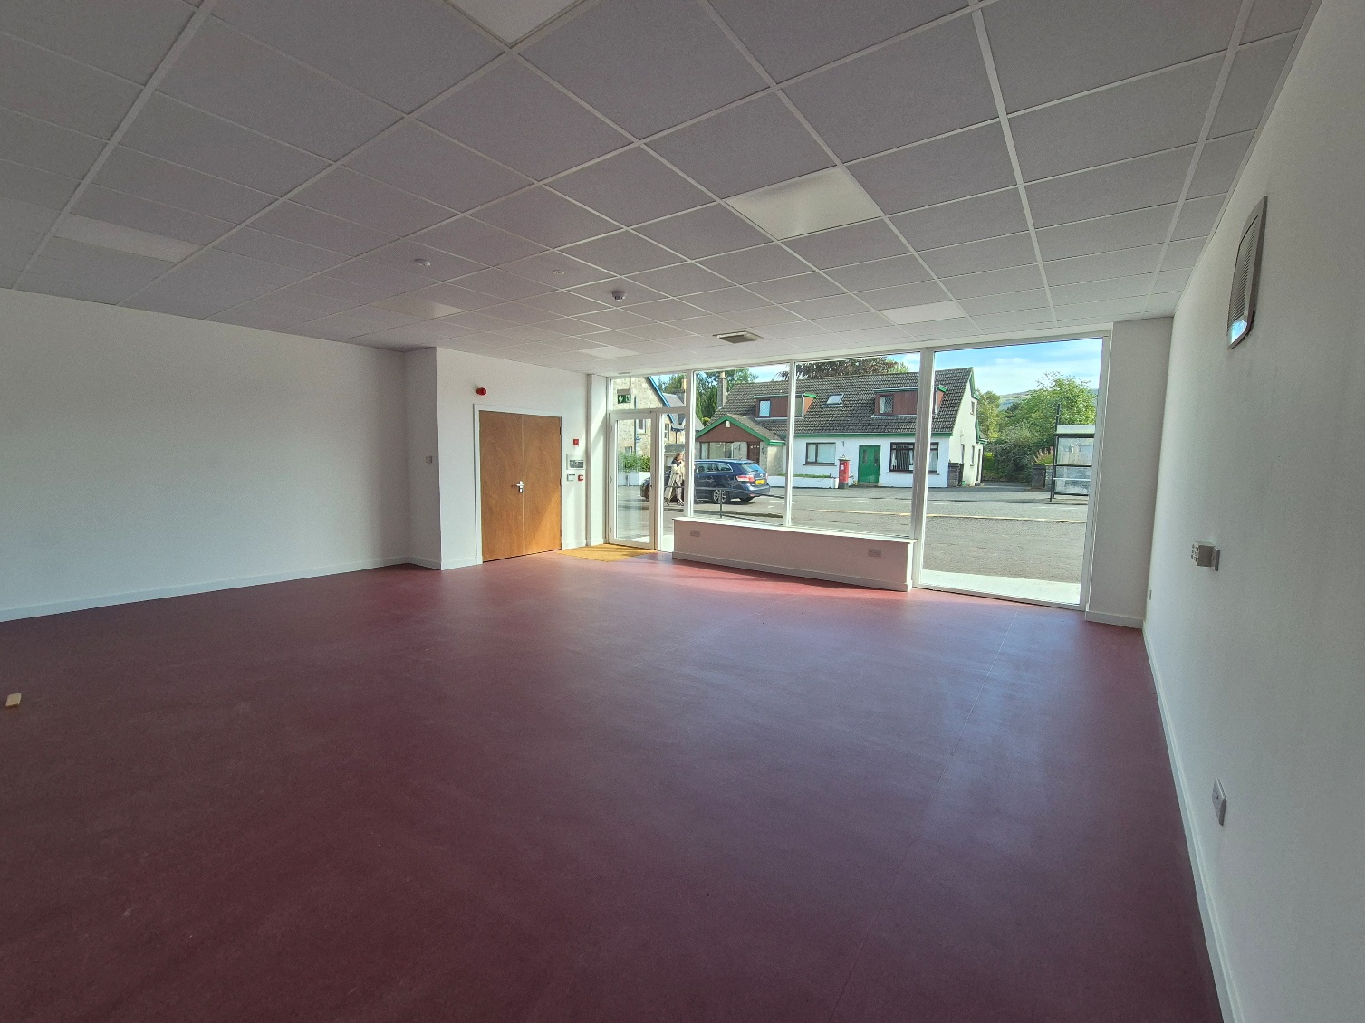

Fassiefern, Main Street, Killin, FK21 8UL

Gross Internal Area 52.2 m² (561 ft²)

**Location**

The shop is situated in the heart of Killin Main Street, a village in the Stirling Council area of Scotland. It is situated near the Falls of Dochart on the A827, that is 2 miles from the trunk road A84, 37 miles north of Stirling, 23 miles from Aberfeldy and 54 miles from Oban. The shop is part of a newly refurbished development that was formally the Co-op. Killin is in the Loch Lomond & Trossachs National Park on the border of Perth & Kinross Council. The Shop is located in a conservation area.

The shop is part of a larger development run by the Killin & Ardeonaig Community Development Trust Ltd (KAT). KAT run their Reuse Shop, Tool Library, Community Fridge, Business & Learning Hub and the KAT office out of the building.

**Description**

The unit is on the market as a retail premise. The unit extend to 52.2m². The front is full ceiling to fall single glazed windows. This consist of a sales area, storeroom and shared toilets and staff kitchen.

**Access**

There is an area out the front for customer parking only for both shops. There is on street parking for up to 8 vehicles, this is not designated shop parking, but for wider community use. There is a public car park at the McLaren Hall 100m away.

**Use**

The unit is on the market as a shop. Businesses which fall under Class 1A – Uses Classes Order 1997 are permitted. It would be a condition of any lease that the use of the premises should not cause a nuisance to the adjacent residential properties. The use of the premises as an Off Sales outlet will not be permitted. Any questions regarding change of use class should be made directly to the Loch Lomond & Trossachs National Park Authority Planning Department on 01389 722600

**Signage**

It is possible to put up sign board on the exterior, it will require planning permission as the shop is located in a conservation area. Any questions regarding signage should be made directly to the Loch Lomond & Trossachs National Park Authority Planning Department on 01389 722600.

**Services**

The building is serviced by water, mains electricity and drainage. KAT will be responsible for water & drainage. Electricity used in this unit will be paid for by the tenant.

**Lease Terms**

A 5 year Full repairing and Insuring lease is being offered. The tenant will be directly responsible for all repairs, utility bills, maintenance, rates and building insurance. The tenant shall be responsible for complying with all Statutory Checks required to be carried out at this property. The tenant will be responsible for a share of common external repairs and maintenance to the whole building of which they are part of. The tenants share for the shop is 50%, this does not include maintenance to the common areas to the flats above the Reuse Shop or the tin shed extension at the back, all other areas are included in this lease.

**Rental Offers**

Rental offers of around £6,000 per annum are invited. VAT is not payable on the rent. Interested parties are asked to note their interest by completing and returning the attached lease application form.

**Repairing obligation**

The subjects are available by way of a full repairing and insuring lease (FRI) on terms to be agreed.

**Rates**

At present we do not have a rateable value for the lease unit. The rateable value is for the whole building, this will be split by the Assessor for Central Scotland once we have a tenant in place. Enquiries regarding any business rates relief should be made direct to the Business Rates department on 01786 233175.

**Fees**

Each party will be responsible for their own legal fees but the tenant will be responsible for any registration dues which may be incurred.

**Reference Check**

Before KAT lease the property they will require to be satisfied regarding the financial suitability of the incoming tenant. A satisfactory financial reference check and a security deposit equivalent to two months rent will be requested.

**KAT Procedures**

Interested parties should be aware that KAT are required to comply with various processes when considering any offers. This could cause delay in KAT accepting any offer or tying up any agreement.

**Further information and viewing**

Interested parties requiring additional information or to arrange a viewing are requested to contact Theresa Elliot, Senior Project Manager on 01567 230040 or email [theresa@killincdt.co.uk](mailto:theresa@killincdt.co.uk)

**Location Plan**

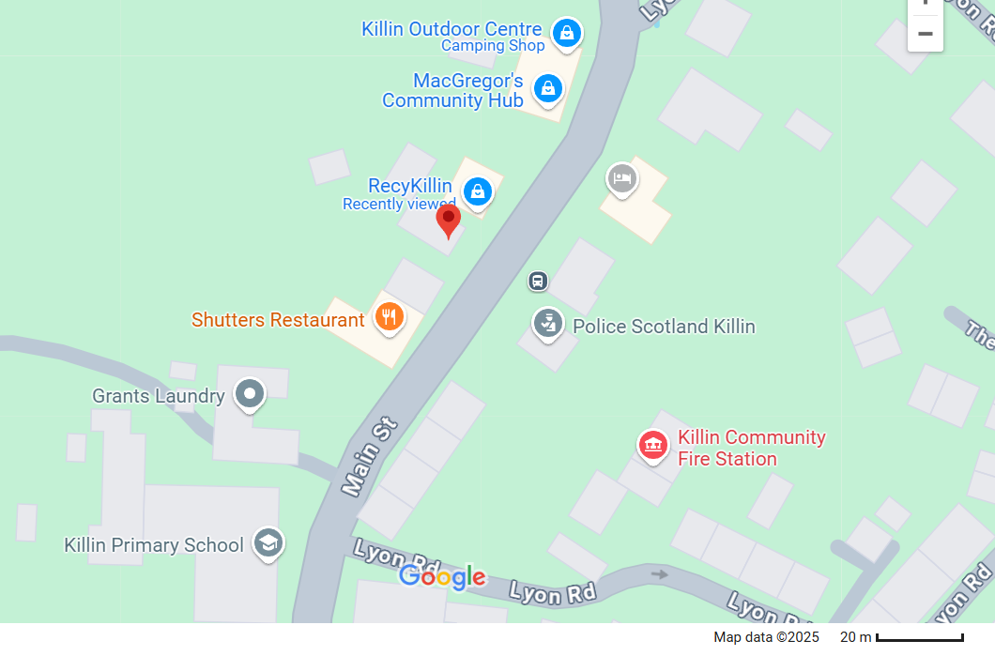

**Important Notice**

1. These particulars are intended as a guide only. Their accuracy is not warranted or guaranteed. Intending tenants should not rely on these particulars but satisfy themselves by inspection of the property. Photographs only show part of the property, which may have changed since they were taken.
2. These particulars are not intended to nor shall they form part of any legally enforceable contract and any contract shall only be entered into by way of an exchange of correspondence between KAT solicitors and the solicitors acting for the tenants.
3. KAT is under no obligation to accept the highest or any offer submitted.

**Prospective Tenant’s Application Form**

**Please send completed form to: Theresa Elliot, Senior Project Manager email:** [**theresa@killincdt.co.uk**](mailto:theresa@killincdt.co.uk)

**Or; by post to; Theresa Elliot, Senior Project Manager, Killin & Ardeonaig Community Development Trust, Fassiefern, Main Street, Killin, FK21 8UL**

**Private & Confidential**

**The information requested below is for the purpose of assessing your suitability as a tenant of the property.**

**1.Tenant Name & Address…………………………………Contact Name……………………….**

**……………………………………………………………………………………………………………………**

**……………………………………………………………………………………………………………………**

**Tel……………………………………………………………………………………………………………….**

**Mobile No……………………………………………………………………………………………………..**

**Email……………………………………………………………………………………………………………**

**Company**

**2. If the lease is to be in the name of a company, please specify Company’s Registration Address, Company No., Companies Bank name and address, account number and sort code.**

**Company Name……………………………………………………………………………………………**

**Company’s registered address……………………………………………………………………….**

**Company no…………………………………………………………………………………………………**

**Companies Bank Details**

**Name and Address of Bank……………………………………………………………………………..**

**Account Number……………………………………………Sort Code……………………………….**

**Guarantor**

**3. Please specify names and addresses of person or persons who would be prepared to act as guarantor for the lease:**

**1………………………………………………….. 2………………………………………………….**

**Bank…………………………………………………………………………………………………….**

**A/c No…………………………………………. A/c No…………………………………………….**

**S/c……………………………………………… S/c………………………………………………….**

**4. KAT requires to be satisfied as to the suitability and financial standing of its prospective tenants, you are therefore requested to sign the following mandate for this purpose.**

**I/We authorise Killin & Ardeonaig Community Development Trust to make all reasonable enquires in connection with my our application to lease this property.**

**Signed………………………………………………………………………………………………………….**

**Name (in capitals)………………………………………………………………………………………….**

**Date………………………………………**

**Signed…………………………………………………………………………………………………………**

**Name (in capitals)………………………………………………………………………………………….**

**Date…………………………………….**

**Applicants should be aware that KAT may apply to a credit reference agency for information on their financial standing.**

**5. Are you VAT registered?**

**Yes/No**

**5.1 If no, is it your intention to become VAT registered?**

**Yes/No**

**If so, when…………………………………………………………………………………………………….**

**6. Name and address of your solicitor**

**……………………………………………………………………………………………………………………**

**……………………………………………………………………………………………………………………**

**Contact………………………………………………………………………………………………………..**

**Tel………………………………………………… Email…………………………………………………….**

**7. Your contact name:…………………………………………………………………………………….**

**Signature………………………………………………… Date……………………………………………**

**The information obtained from you and third parties on this form will be used in connection with assessing your suitability as a tenant of KAT. This information may be shared with appropriate directors within KAT. By signing this form where indicated above, you are agreeing to this.**

**If you have any queries regarding your application please contact Theresa Elliot on 01567 230040 or email theresa@killincdt.co.uk**